**Balanced Scales Tasks**

1. Find the value of each shape. Assume the scales are balanced (equal weight on both sides), and treat these two problems separately.



a. b.

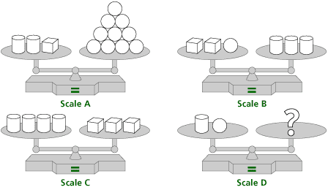2. Assuming that each scale is balanced, what shape(s) should be on the right side of scale D? Again, explain your reasoning.

Sources: Billstein, R., Libeskind, S., & Lott. J. (2010). *A Problem Solving Approach to Mathematics for Elementary School Teachers* (10th   
 edition). Boston, MA: Pearson/Addison Wesley.

<https://www.learner.org/courses/learningmath/algebra/images/session6/6a6_shapes.gif>