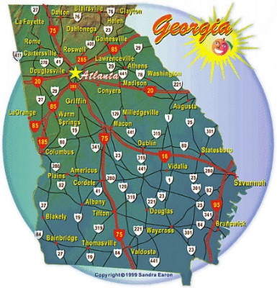
Dr. Caroline Collins
Lecturer in English
Gordon State College
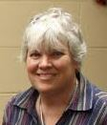
FALL 2017 OFFICE HOURS
BARNESVILLE CAMPUS HOURS:
Tues. & Thurs.: 3:30 - 4:30 PM
Friday: 12:00 – 3:00 PM
FORT VALLEY HOURS:
Mon. & Wed: 9:00 – 11:00 AM
Also available by appointment
Email: ccollins@gordonstate.edu
Office phone: 5098

