Online/Hybrid Course Checklist
Non-D2L Tasks
-Reserved classrooms for any on-campus assessments using R25.
-Email your department’s academic aid with “blurb” information to be displayed on the webpage here under “Course Schedules” and “Online/Hybrid” courses. This should include the dates, times, and locations of any on-campus meetings.
-Send a welcome email to the students (through classlist in Bannerweb) announcing any on-campus assessments and/or mandatory live sessions. (Approximately 3 days before the beginning of the course).

Copying/Importing Content Tasks
-Copy content from one course shell to another. (Advice: If you are copying 70% or more of a course, it is best to copy the entire course and then remove the items that you will not be using).
-If you are using a publisher’s testbank, download the test bank from the publisher’s website and import it into D2L. You can then make quizzes from the question library.

Building Content in D2L
-Create a module for the syllabus. In the syllabus make sure the following are included:
- Contact information/Office Hours
- Course Objectives and Outcomes
- Policies related to late work & communication in online class
- Any dates, times, locations of on-campus meetings
- An outline of major assignments & their due dates
- Links to external resources (ie: Textbook Resources, Turnitin, Remind, etc)
-Create a “Welcome to the Class” News item that appears on the course homepage. You may choose to provide instructions of how to access the syllabus, what email to use, as well as the on-campus meeting dates.
-Delete old news items (they will be copied over from the prior semester).
-Go to “Content” on the navbar and select the different links in the modules to make sure all are organized and are opening correctly.
-If you have placed date restrictions on modules, make sure to change those dates to the upcoming semester’s schedule (the old release dates will be copied over).

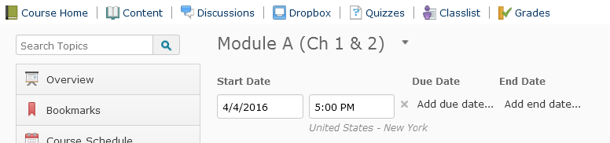

-You may choose to edit the restriction/due dates of assignments in bulk.

-If you edit the assignment due dates individually, navigate to the quizzes, dropboxes, and discussion area. Edit each assignments and alter the due dates for the upcoming semester (the old due dates will have copied over).
-Make sure to link the activities (quizzes, dropboxes, discussions, etc.) back to the content area (in the appropriate module). You can do this by choosing “Content” and “Add existing activities” and choosing the correct type of activity. This makes it easier for the students to locate the activity.
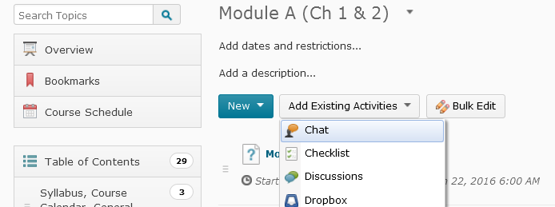
-If you have students read certain articles from GALILEO, you may choose to make a reading list.

Setting up the Gradebook in D2L
-Complete the “Setup Wizard” (from “Grades” on the navbar) first. Make sure to choose “calculated final grade” (even if you plan to adjust it).
-(For a new weighted, gradebook), create categories (grey bars) first and then items (white bars). If you are using a points scale, only create grade items.
-You may choose to release the final grade calculation to the students (if you want them to see their average at any given time).
-Make sure that your grade items are linked to the appropriate assignments (quizzes, dropboxes, discussions). You can see this in the “manage grades” area by hovering over the “association” icon. (If they are not associated, go to the respective activity (quiz, discussion, etc.) and edit it. In the “assessment” tab, choose the grade item that it should be associated with).

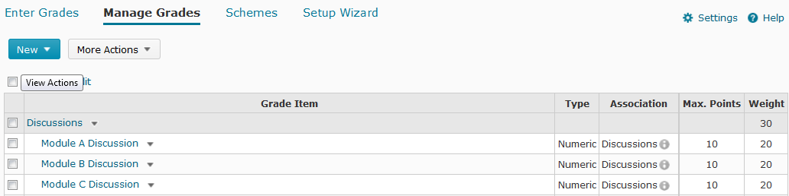

Discussions within D2L
-Consider devising a “General Help” discussion within D2L and linking it to your syllabus module. Explain in the syllabus that this is a place for general questions and FAQ from the instructor (and specific questions can be emailed).
-Make sure that for every forum (grey) there is also a topic (white). Students can see the information in a forum but they can only post in topics.
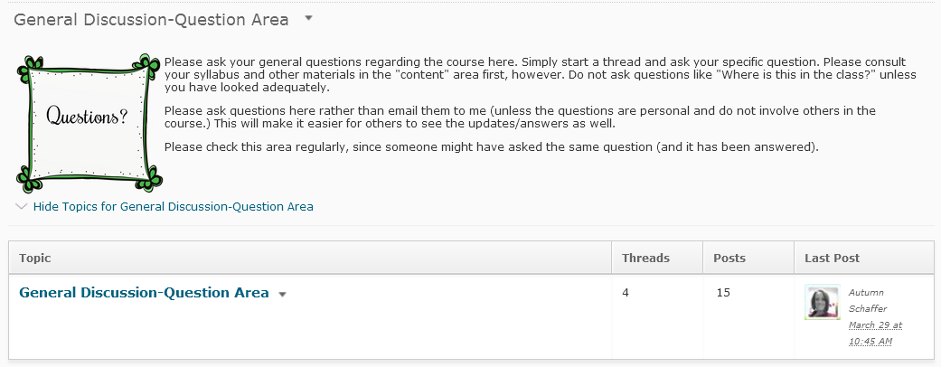
-You may consider putting students into groups for discussions (if you have a large class). You may type the prompt in the forum (so that all can see it). You may choose to give students different prompts, however, and those will need to be posted in the individual topic areas. Note: You cannot connect grouped discussions to a single gradebook item.
Notes about Discussions:
- Students cannot edit a discussion after they post it. It is advised that they type it in Word and copy/paste it in.
- The instructor will not be able to create discussion groups until the students have been loaded into the class (usually 2 days before the class begins.

Quizzes within D2L
-If you are building a test from scratch, consider using Respondus to build the quiz from a Word document and import in into D2L.
-If you need to print a quiz from D2L, you can pull it out via Respondus as well.
-Consider using Random Sections in the quiz (so students are given different questions in a different order.) Also consider using a test bank of questions (more questions that what they will be provided on the test).
-Make sure the “auto grade” and “allow attempt to be set as graded” areas are checked and the quiz is associated to a grade item (under the “assessment” tab).
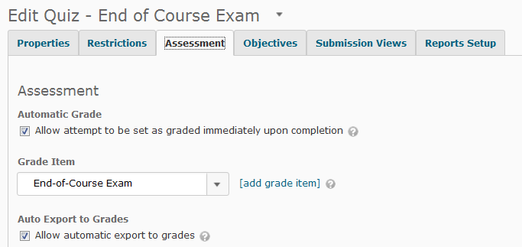
-Change the submission view dates (if you provided an additional view for students to see the questions they missed after the exam). The old dates for the additional view will copy over.
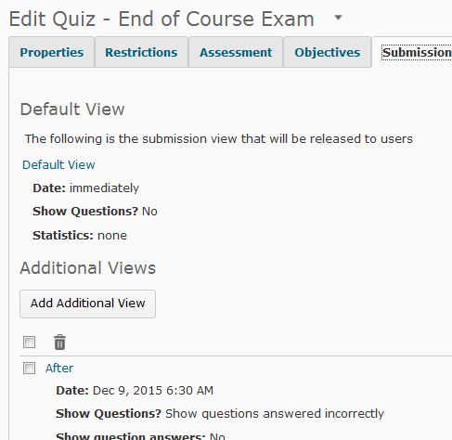

Dropboxes within D2L
-If you want the dropbox associated with Turnitin, make sure to enable “Originality check” and “allows submitters to see originality reports” (at the bottom).
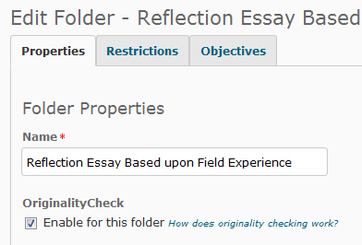
-You may choose to associate the dropboxes (or discussions) with a D2L rubric.

